The Influence of Plague on Art from the Late 14th to the 17th Century
Sardis Medrano-Cabral

The second pandemic of plague during the mid 14th century significantly affected European culture, the idea of death, and religion. During this time, many artistic representations captured moments of terrible misfortune, sarcasm, and—sometimes—hope. This period often was characterized by death and its many, constantly evolving representations.
From the late 14th to late 16th century art was unpredictable, altered by ethnic expansions, military interventions, and changes in religious attitudes (Johnson, 2003). After the conversion of Constantine, virtually all of Europe was opened to Christianity and this had a profound effect on art, lasting more than a thousand years. The medieval artist strove for realism. Churches and monasteries were covered in inscriptions, paintings, and sculpture that portrayed biblical scenes or saints. In many of these early paintings and sculptures, death was represented as a passage between life on earth and the illumination. After the Black Death, death was feared and sometimes considered God’s punishment for sin.
Spreading inexorably from central Asia to China, India and Russia this awesome pestilence devastated Europe. The Black Death left behind an undeniable sense of despair and sadness. This was manifested in many cultural and artistic forms. The artistic expression at the time mirrored people’s personal experience with death. The plague began decimating Europe’s population rapidly and there was no satisfactory explanation. Because it was a time of strong religiosity and superstition, people began believing that dying of plague was the result of the condemnation of God and preceded an eternity of suffering. As explained by many, this pestilence was brought about because of the people’s many sins, forcing men and women to recognize the fragility of life and to scrutinize it more closely. Many sought personal salvation and ways to reach spiritual enlightenment. Among the examples is the mural painting, “The Procession of Saint Gregory” ca. 1300. Among the many functions of this piece was to induce repentance and respect for the role of religious rituals and the holy church in matters of protection (Fig. 1).
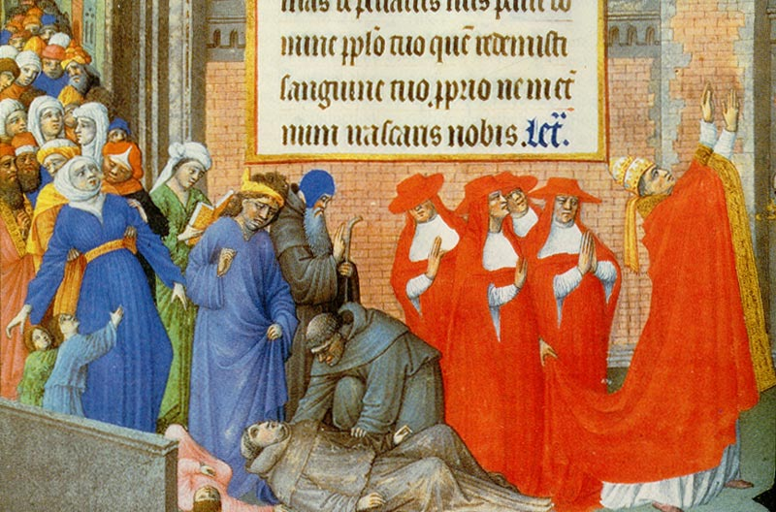
Figure 1. Procession of Saint Gregory, ca. 1300, Musee Conde, Chantilly.
Because of the Black Death and the recession the building industry was also affected. Building in the medieval Europe would never be as extravagant as in the century before the Black Death. If the Black Death did indeed have a direct impact on landowner building practices, it was chiefly in the area of self defense (Platt, 1996). The ostentatious castles of the late 14th century were mainly used to restrain unruly tenants rather than to protect from war. Most of the building’s expenses were covered by the landowners and completion of monasteries and churches was funded by the lords who consequently had the right to a prominent tomb display.
The Black Death powerfully reinforced realism in art. The fear of hell became horribly real and the promise of heaven seemed remote. Poor and rich were left with a sense of urgency to ensure their salvation. Educated rich men and women read about the Day of Judgment and thought carefully of making a bona mors (a good death) or, if that were not possible, at least having a sumptuous funeral and tomb.
The most frequent feature of the medieval tombs is the sleeping recumbent figure with a peaceful face in repose. In some cases, the recumbent figure of death also was violent or cruel such as the case of Condottiere Guidarello Guidarelli from 1525 by Tulio Lombardo, in the Academy Gallery in Ravenna. In that case, the sculpture is a soldier that is mortally wounded, marked by suffering. In contrast, the church of Saint-Etienne in Bar-le-Duc in the Lorrine region of France now houses a tomb sculpture called Le Transi, or “tomb figure” by Ligier Richier (Fig. 2); the tomb holds the heart of René de Chalón, Prince of Orange. The young prince died in battle in 1544 at age 25. Tradition holds that, at his own request, his tomb portrait was not a standard figure but a life-size skeleton with strips of dried skin flapping over a hollow carcass, whose right hand clutches at the empty rib cage while the left hand holds high his heart in a grand gesture. But what is the real meaning of this? Is this an arrogant gesture or a penitent one?
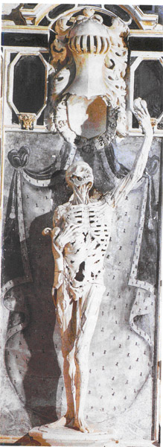
Figure 2. Ligier Richier, Le Transi Tomb of Renee Chalon 1547. Church of Saint-Etienne, Bar-le-Duc.
Most of the tombs during the 14th through 16th century share the same general characteristics—the antithesis of portraits of elegance and status. In the late 15th century, the sleeping figure moves closer to the corpse, a transi, which literally means “stiff”. The macabre transi is a decomposing corpse inhabited and gnawed by worms, with shreds of flesh hanging from it. But the macabre figure of death is not simply an agent of destiny; he communicates with a hidden world which, in the 15th and 16th century, he helped reveal: a world that emerges from the depths of the earth and from the interior of the body, inhabited by worms, toads, snakes, and hideous monsters (Aries, 1985).
During the 14th century, another common scenario in religious portraits was the deathbed scene, a dying man or woman surrounded by a kind of social ceremony. In the portraits of death scenes after the plague, the sick person is left alone and the room is emptied in the presence of death, generally represented by an angel or a decomposing skeleton. By the end of the 16th century, portraits are combinations of both living and death imagery. The macabre transi of early 15th century is replaced by a clean and dry skeleton or morte seca.
Omnia vanitas translated as “all is vanity” reflects the idea or mood of most Europeans. Vanitas, or oneself, is the suggestive boost of carnality, a taste for life and nature, the last iconographical shoot of the Black Death. As explained in the verse of the “Three Quick and Three Dead,” three corpses admonish three cavaliers: “What you are, we once were, what we are, you shall be”. The Vanitas was commonly placed in contrast with death as the future; death can be seen as a skeleton reflected in the mirrored image of a woman or lurking beside her. An example is the portrait by Baldung Grien of a young mother with her child unaware of death’s presence, looming behind his prey (Fig. 3).
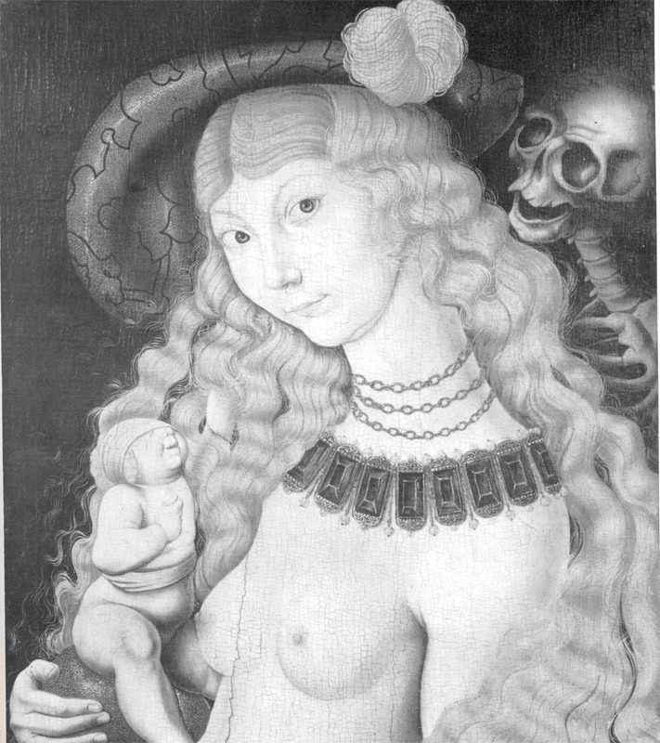
Figure 3. Hans Baldung Grien, The Young Woman and Death, (16th century) Museé d’Art.
Most of the paintings at the time attempt to represent the triumph of death over their ignorant prey, but also in some cases the fearless defying vanity of people as the case of the Belle Rosine by Antoine Wierts of 1847, Museé Wiertz, Brussels, in which the standing figure of Rosine serenely faces a suspended legless skeleton. This type of art is determined to reveal the illusion that lies beneath appearances (Aries, 1985). Another very common style is death waiting upon a deathbed in a room or lurking around the city as exemplified by the painting “Plague” by Arnold Böcklin, a blend of realism, naïve symbolism, and strident colors (Thuillier, 2002) (Fig. 4).
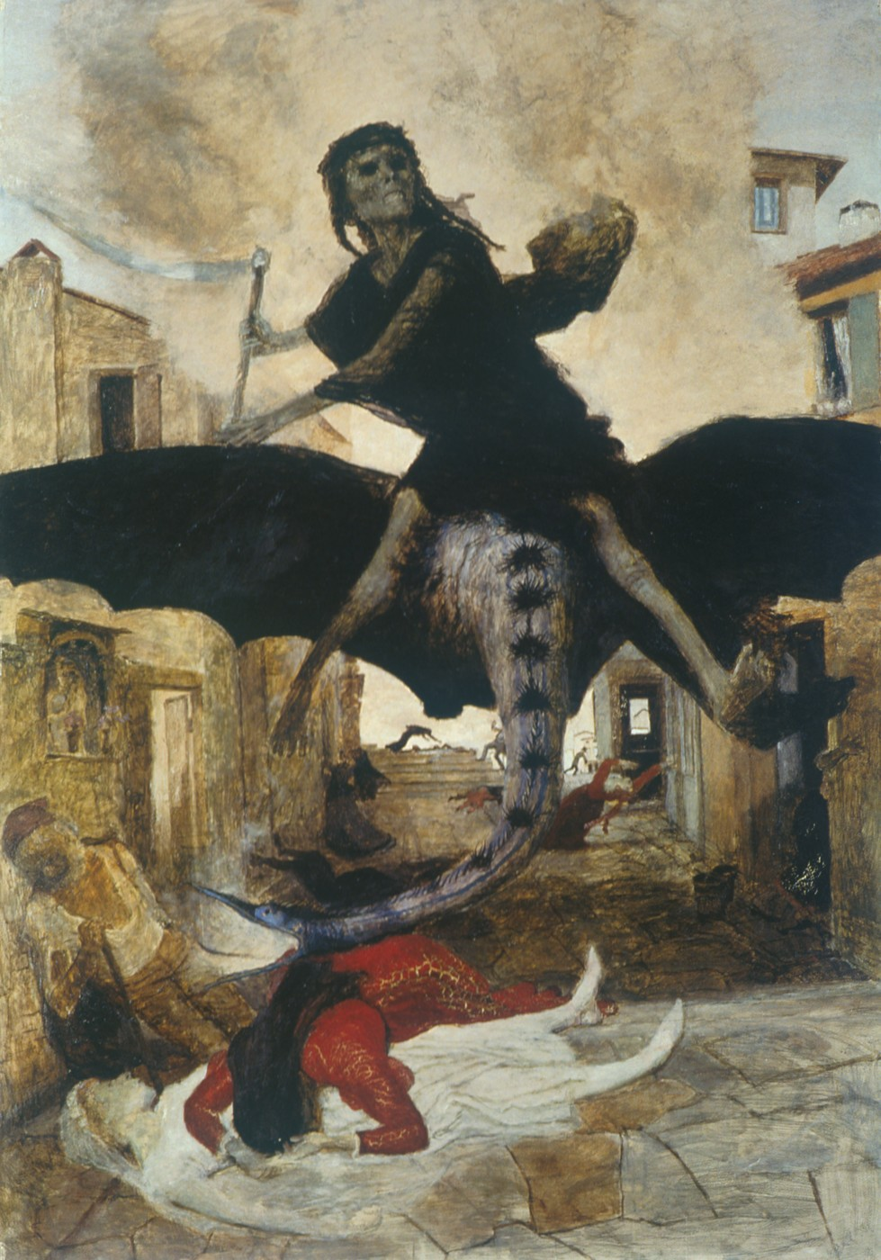
Figure 4. Plague, Arnold Böcklin 1898. Kunstmuseum, Basel (Switzerland).
The trauma of the Black Death gave rise to the most popular artistic channel for the representation of death, the Dance of Death. There are indications that first the dance macabre was performed, then poetized, and finally painted. Before the15th century, the Dance Macabre was traced on walls of churches and charnel houses across Europe, gathering in its train rich and poor and young and old, exemplified by the fresco of Eure-et-Loir. In Europe every victim was danced off to hell no matter what: sudden death was escalated to sudden damnation (Binion, 2004). The dance macabre, based on folk superstition represented by the skeletons themselves, or accompanied with the living had a second social and spiritual lesson, that death is always coupled with the living. In the dance of the death, the corpses often tug or draw the living to death (Cohen, 1982) (Fig. 5).
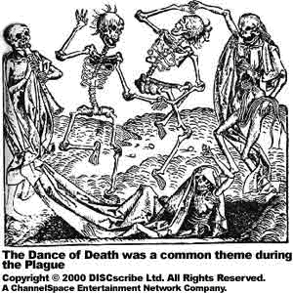
Figure 5. Dance Macabre, in graveyard of the church of St. Magnus at Magdeburg.

Most historians interpret the emergence of the radical death iconography as a manifestation of the traumas that people suffered during the plague epidemics. However, the iconography also can reflect the passion for life, how strongly people were attached to it, and how bitter it was to lose it.
References Cited:
Aries, P. 1985. Images of Man and Death. Harvard University Press, 271 pp.
Binion, R. 2004. Europe’s culture of death. Journal of Psychohistory 31:395-412.
Cohen, J. 1982. Death and the Danse Macabre. History Today.
Johnson, P. 2003. Art: a New History. Harper Collins Publishers, 777 pp.
Platt, C. 1996. King Death, The Black Death and its Aftermath in Late-medieval England. Toronto Press, 262 pp.
Thuillier, J. 2002. History of Art. Flammarion, 634 pp

